Thanya Nguyen

Lab report 3 – Kmeans Cluster

10/10/2023

COSC 425

1. Question 1 – Created the function
2. Question 2 – Used the function for different K Vals

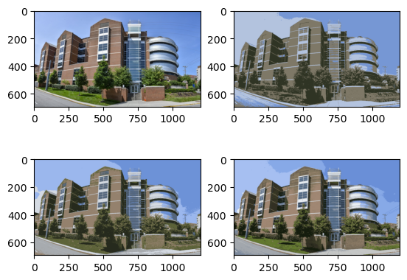

In these 4 pictures, I believe that all of them look acceptable because the picture is not super vibrant to begin with, especially compared to the other photos.

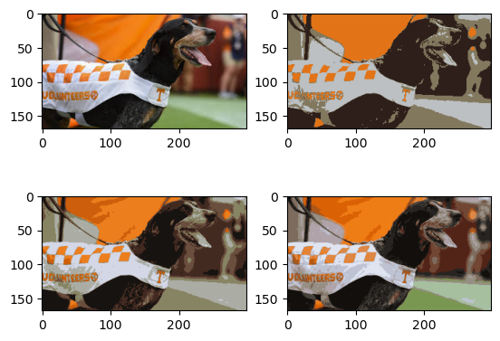

In the graph with smokey, I believe the K=4 on the top right is unacceptable because the image looks very low quality and the dog is not as detailed as it should be. Compared to the original smokey picture, K=4 is quite blurry. I like the vibrant colors for all the pictures though

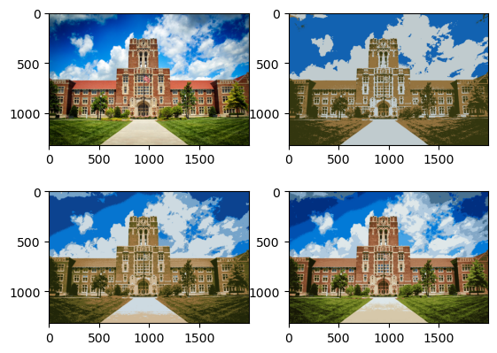

In the Ayreshall.jpeg, the orginal picture is very detailed and saturated. I believe that K=4 and K=8 take away a lot of the details and dimensions the picture has. K=16 is acceptable because it is pretty close to the original picture.

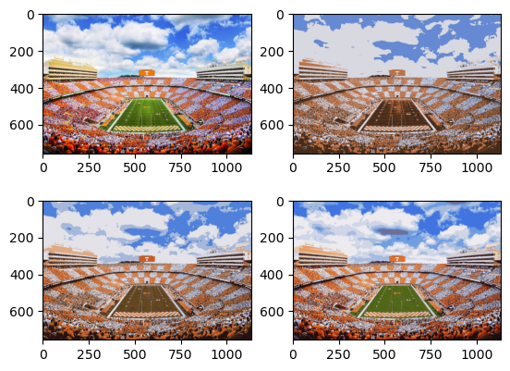

CheckNeyland.jpeg is a very vibrant picture, in K=4 a lot of the vibrancy like the grass is taken away. This is unacceptable because the grass field area is the center focus of the picture. K=8 is somewhat acceptable because it looks very “fall ball” autumn vibes. K=16 is the most detailed to and looks like a slightly duller version of the original.

1. Question 3: make a histogram plot for each picture at K=4,8, and 16

